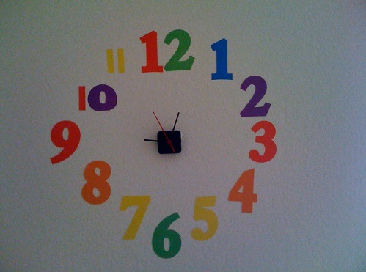

**Room 301 Daily Schedule**

Capturing Kids Hearts

Differentiated Instruction (DI)

Shared Reading

Math Workshop (MWS)

Handwashing/Bathroom

Lunch

Recess

Math Needs Based Instruction (NBI)

Science/Social Studies

Writing